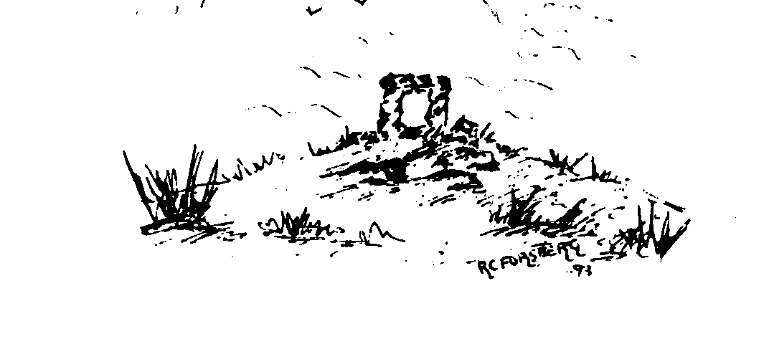

Insch Medical Practice

Online Services - Patient Registration Form
If you would like to register for this online service please complete one form for each member of the family and return to the Practice in person, along with a valid form of identification, for example photo ID or your passport.
Once you are registered the practice will give you the information that will enable you to create a username and password.
Patient details | Please complete in BLOCK CAPITALS
Patient forename
Patient surname
Date of birth | D | D |  | M | M |  | Y | Y | Y | Y
Email address
This email address will be used by your practice to send you notifications and reminders.
Mobile number
Signature
(if signing for yourself)

Date | D | D |  | M | M |  | Y | Y | Y | Y
Completing the form on behalf of someone else?
Print your forename
Print your surname
Relationship to patient
Signature

Date | D | D |  | M | M |  | Y | Y | Y | Y

Patient ID seen
Type of ID
Staff name
Date | D | D |  | M | M |  | Y | Y | Y | Y

